LanSchool Logging in to Multiple Machines

Select the machines you want to log in to from the main menu:

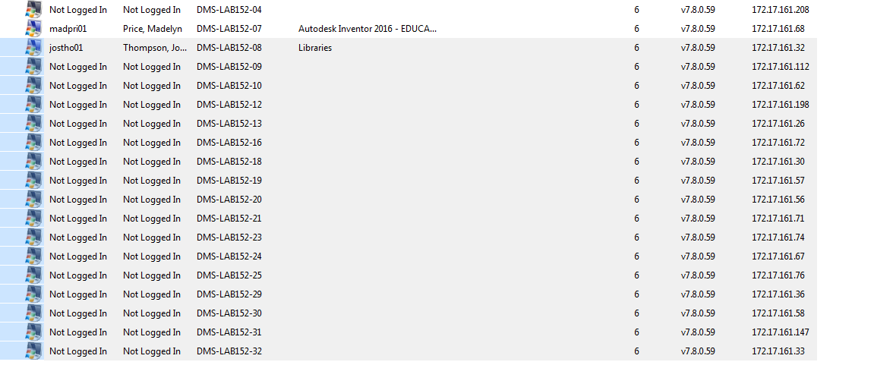
Go to Administrator and select Log On Selected Students.
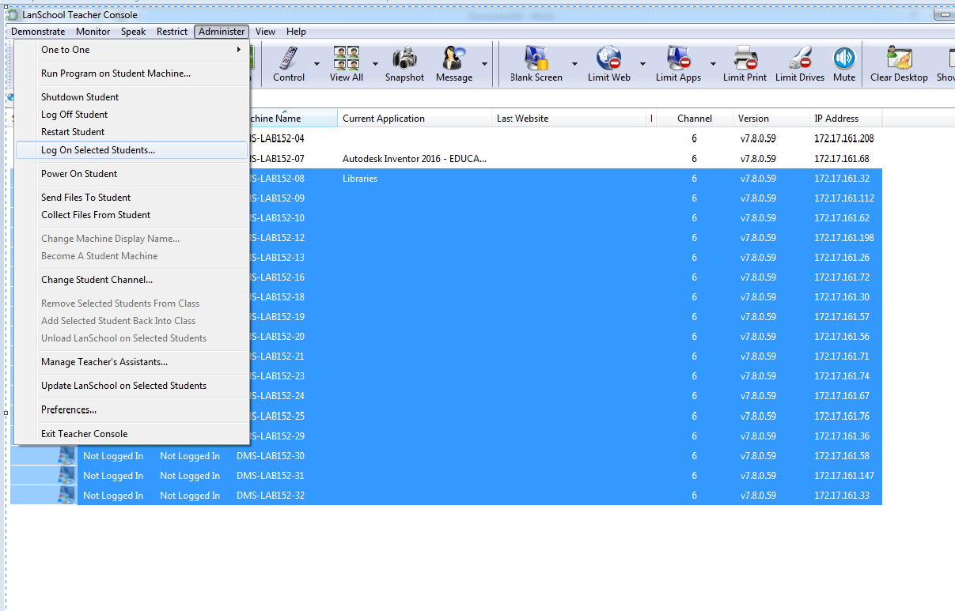
Enter the user name and password and select ok.
