Lanschool Powering up Machines.
The LanSchool icon is a green wreath and is located in the hidden icons on the bottom right corner of the screen. Locate and select the green wreath icon.
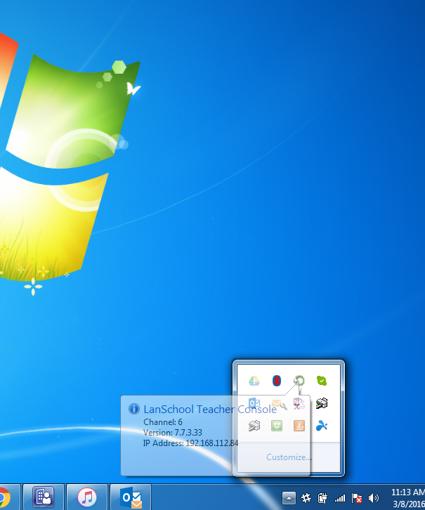

Go to Admin and select power on students.
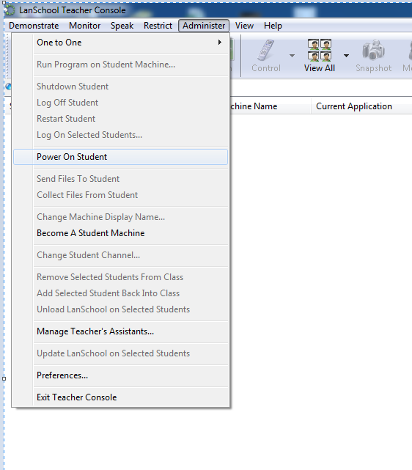
High light the machines you want to power on. And select the Power On button.
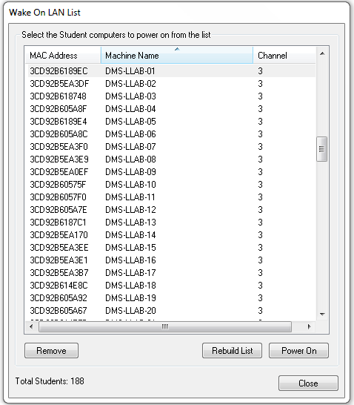

Note: If no students are present to power up you may need to rebuild the list. To do this turn all the machines on manually, when they are at the log in screen select the rebuild list button. This only needs to be done once.

