Go to setting and select Icloud:
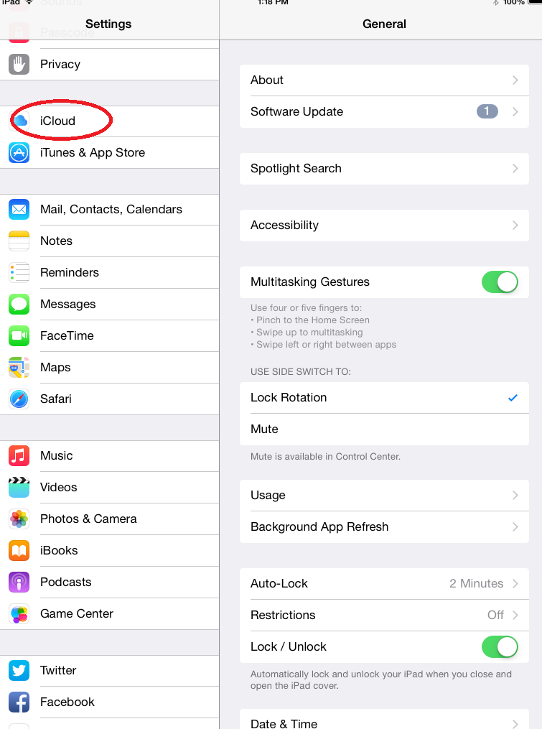

Select Back Up
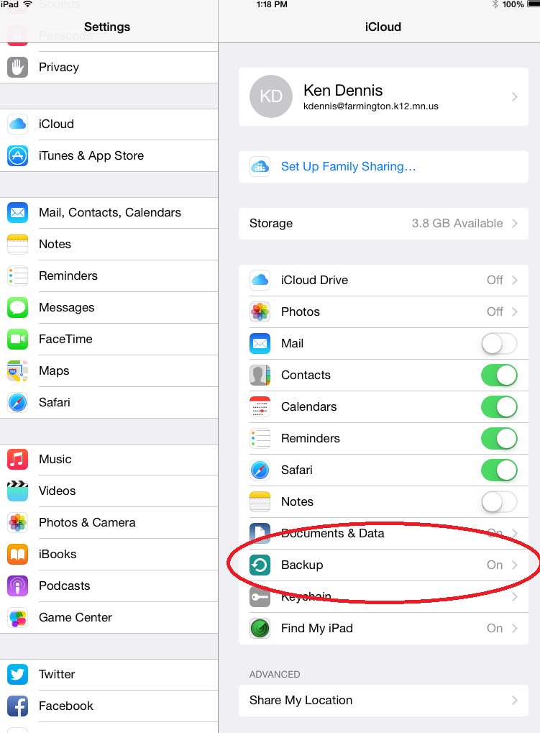

iCloud Backup should be turned on. This will back up daily, when your Ipad is plugged in and charging for an extended period of time. You can force a backup by selecting Back Up Now. You can also check to see when the last back up occurred.
