To set up a second tab in Internet Explorer, open explorer and go to the page you want to set up. Left click once in the address bar to high light the address.

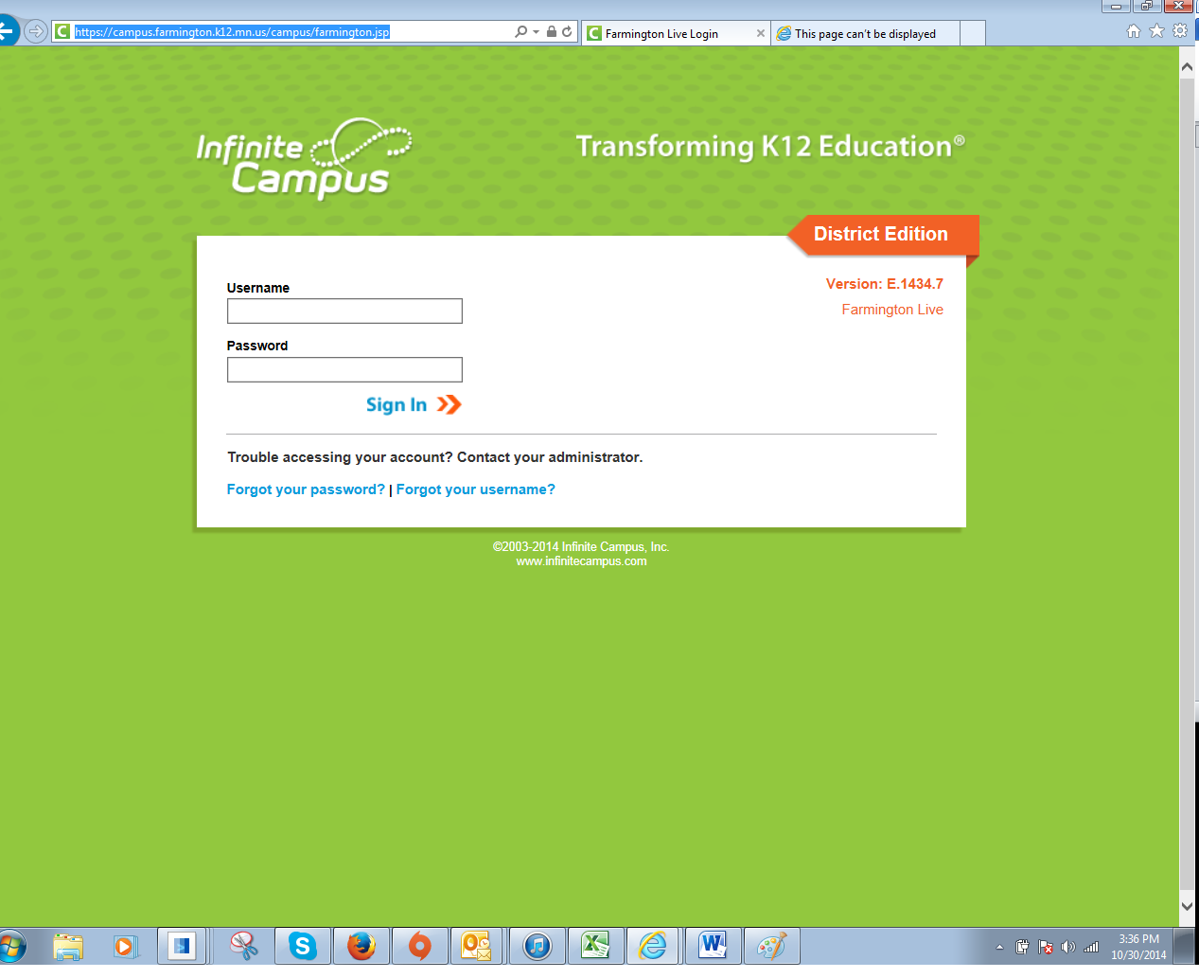

Right Click the highlighted address and then select Copy.

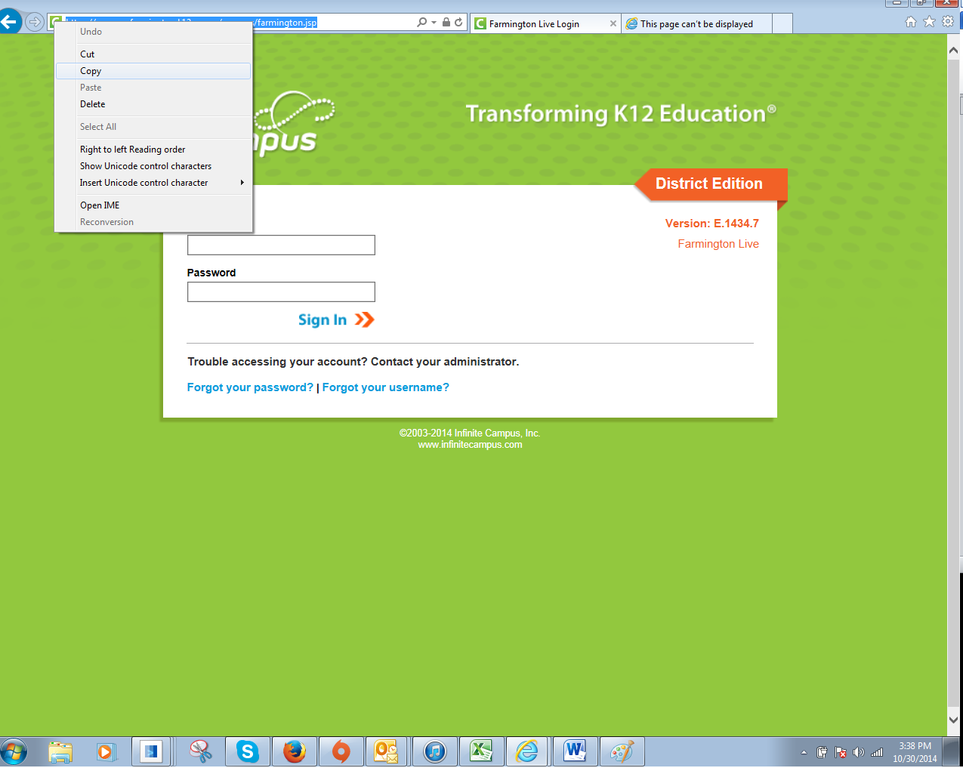

Go to the gear in the upper right corner and left click once.
Go to internet options and left click.

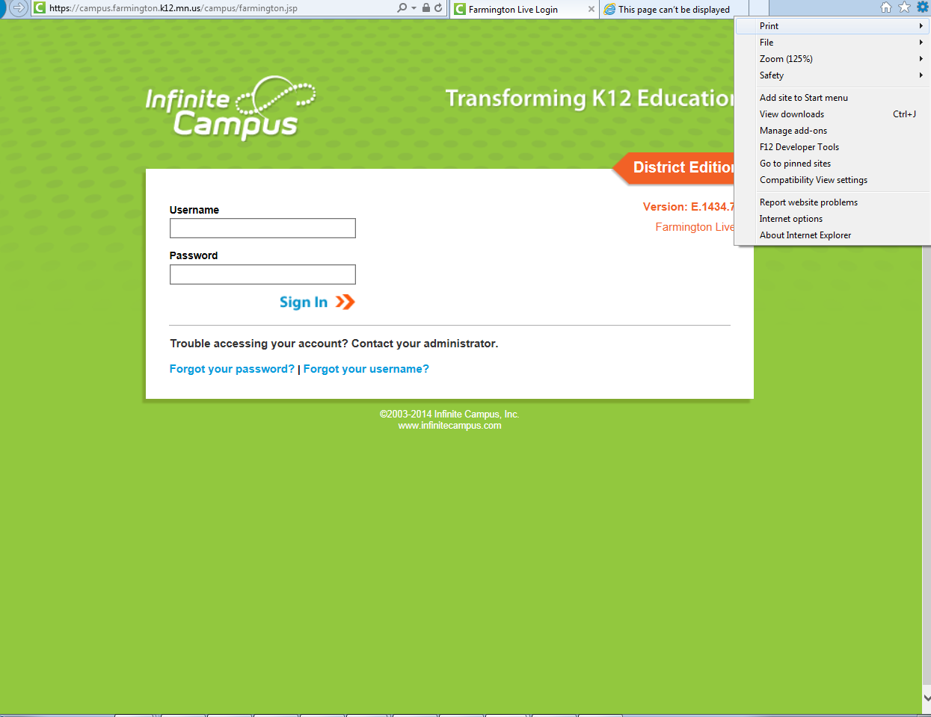

Your defaulted home screen will be displayed. Left click at the end of the address to see the curser then hit enter.
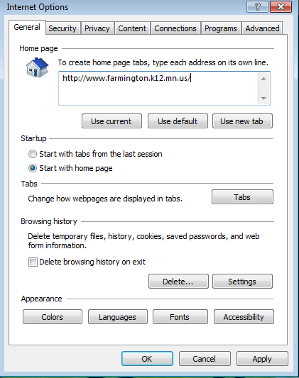
. Right click and paste the link for your second tab under the first link. Select apply
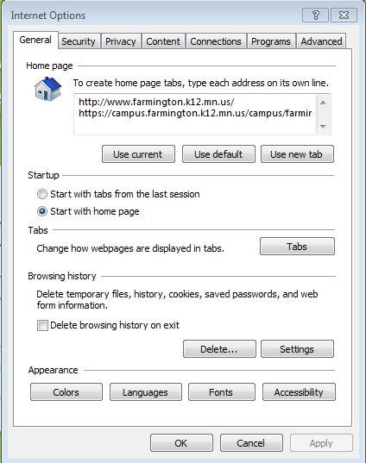
\
Close your browser, and then reopen. The homepage will display tab one, your page on tab two.

