Skyward Employee Access

## **TrueTime Clock Instruction Sheet**

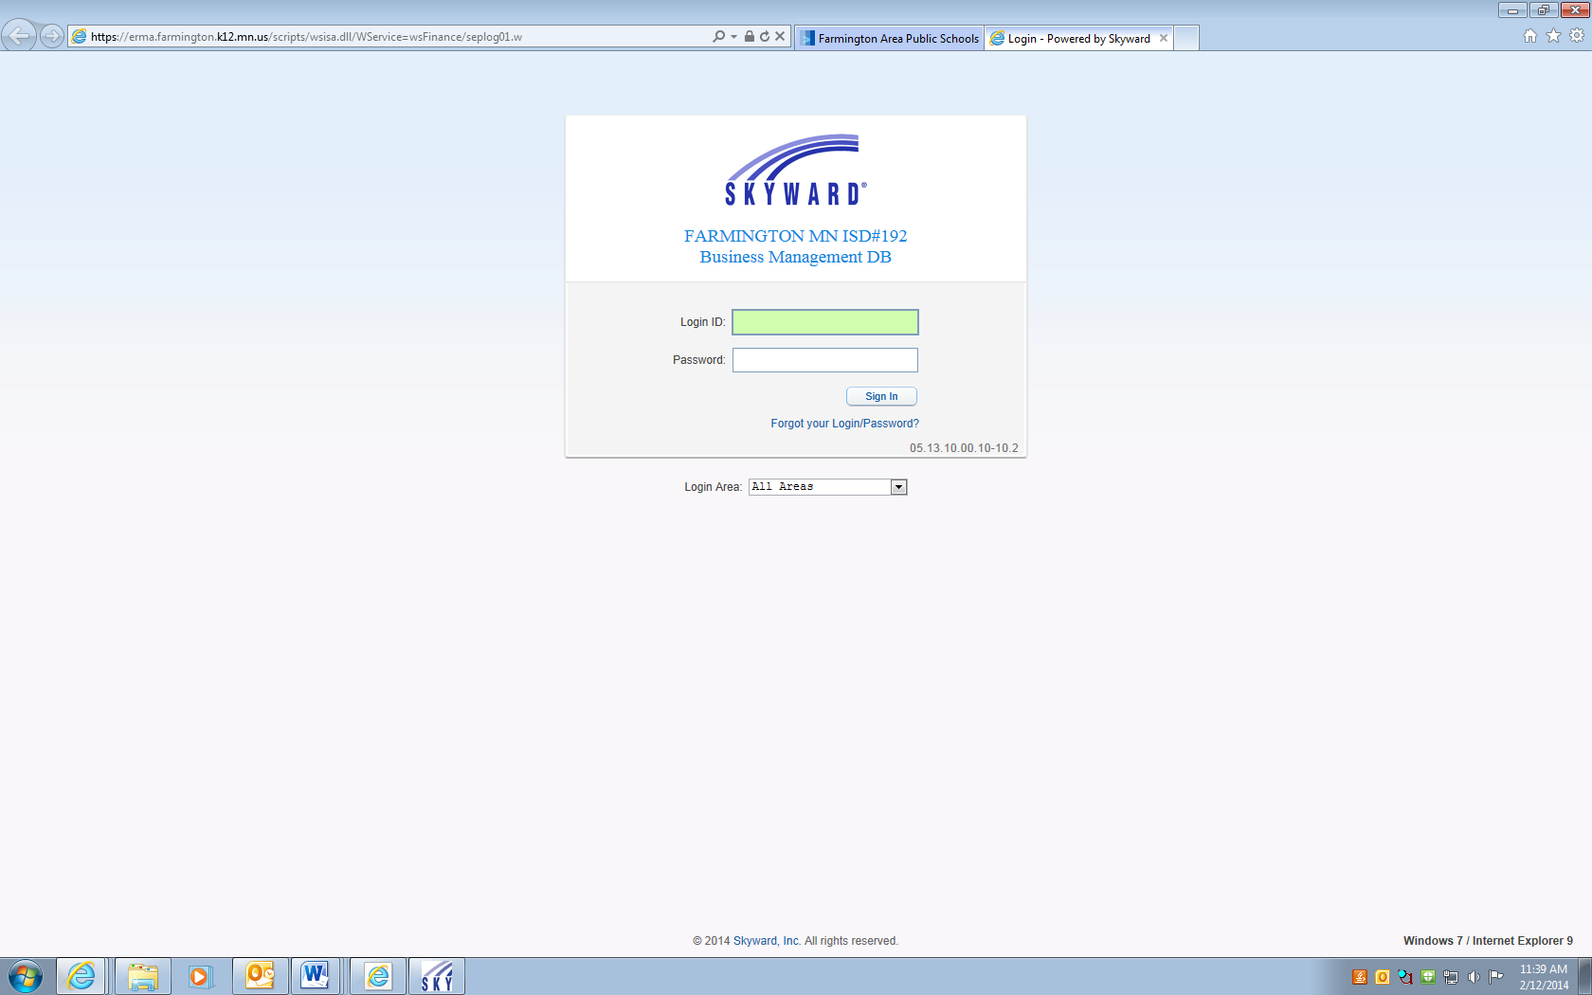

1. Go to the District website ([www.farmington.k12.mn.us](http://www.farmington.k12.mn.us)) and click on Staff Resources. Then click on the link Employee Resource Management Assistant (ERMA).
2. Enter your login ID and password. This is the same as your network ID and password. If you have login issues please call the Tech Department at 651-463-5055.

Steps For Clocking In and Out

Clocking In:

1. Click on true time
2. Click on quick entry
3. Click on the In box
4. Click on exit

Clocking Out:

1. Click on true time
2. Click on quick entry
3. Click on gone for the day
4. Click on exit

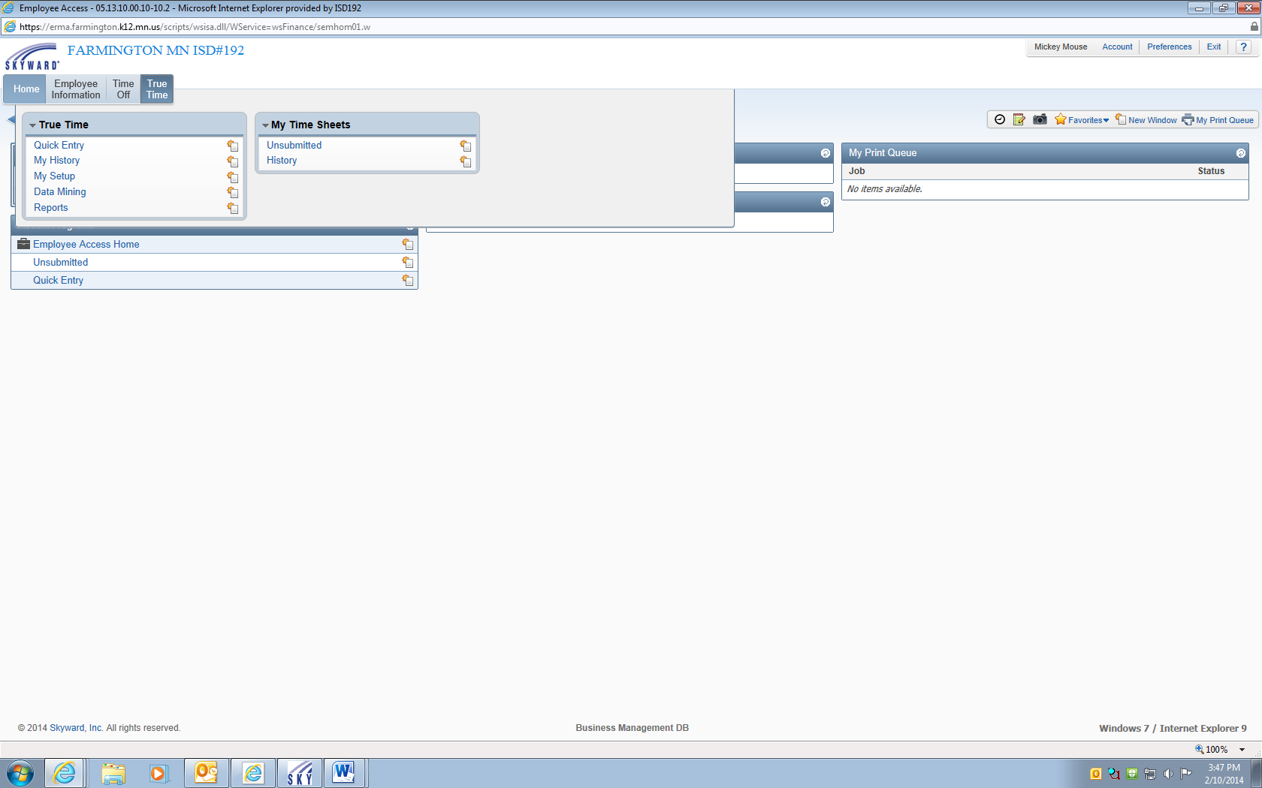

Step 4

Step 3

Step 2

Step 1

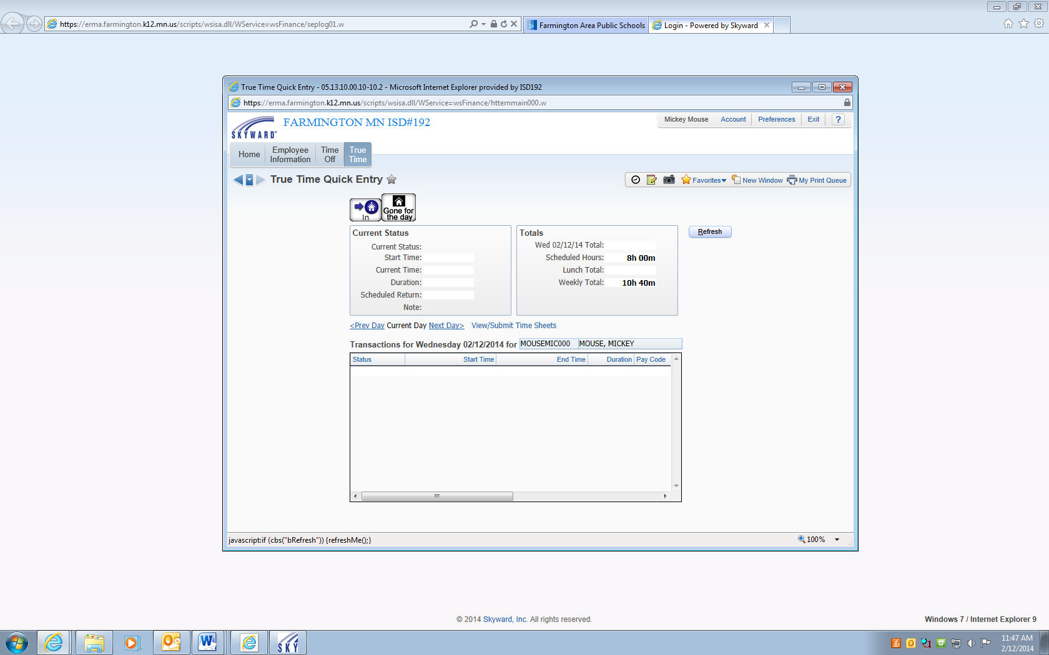

Those Who Have Multiple Jobs

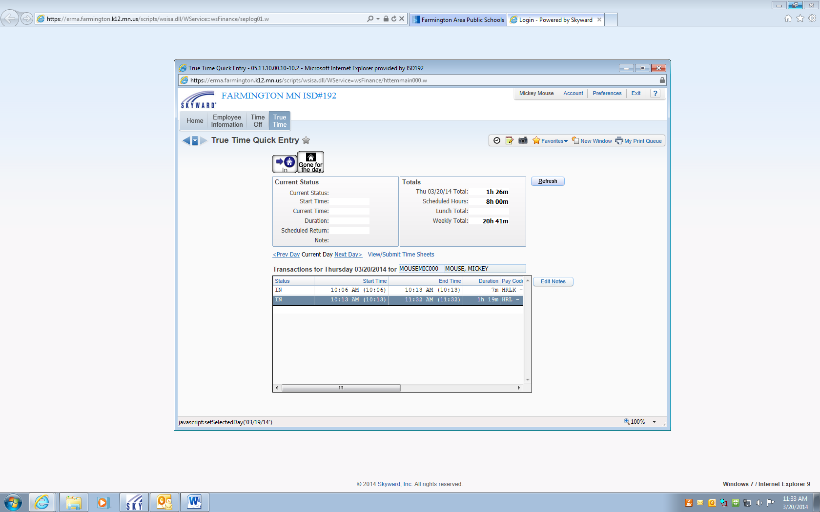

Step 4

Step 3

Step 2

Step 1

Steps ~

1. Click on “In”
2. Under job selection you will need to put a checkmark next to the job that you are working
3. Click on “Select”
4. Make sure you click on exit so your screen doesn’t stay active for the next user

Custodian Example ~ If you are a custodian working late shift you will want to make sure you select the HRL+LATE SHIFT code. If you are working a Community Education event you would select HRL COM ED CUS.

Educational Assistant ~ For your regular job you will select the HRL code but when working for Kid Connection you would select HOURLY KID CON.

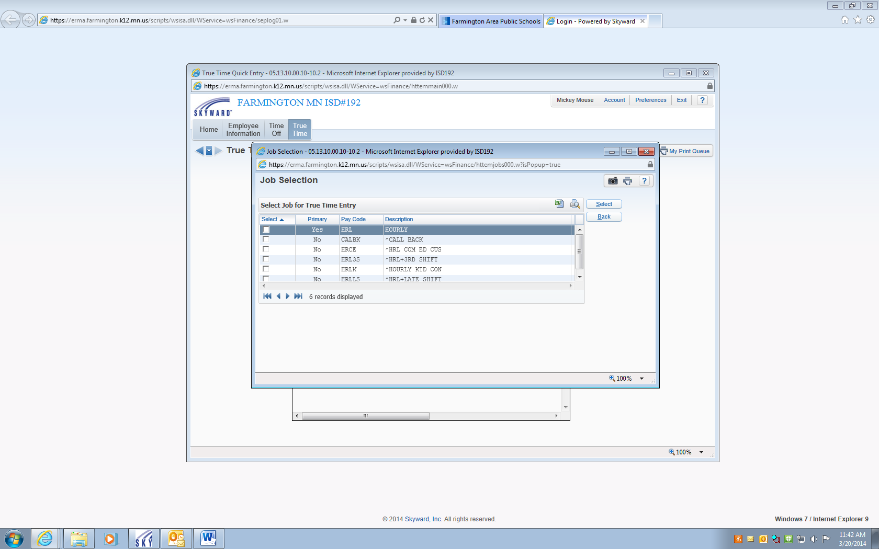

Time Card Corrections

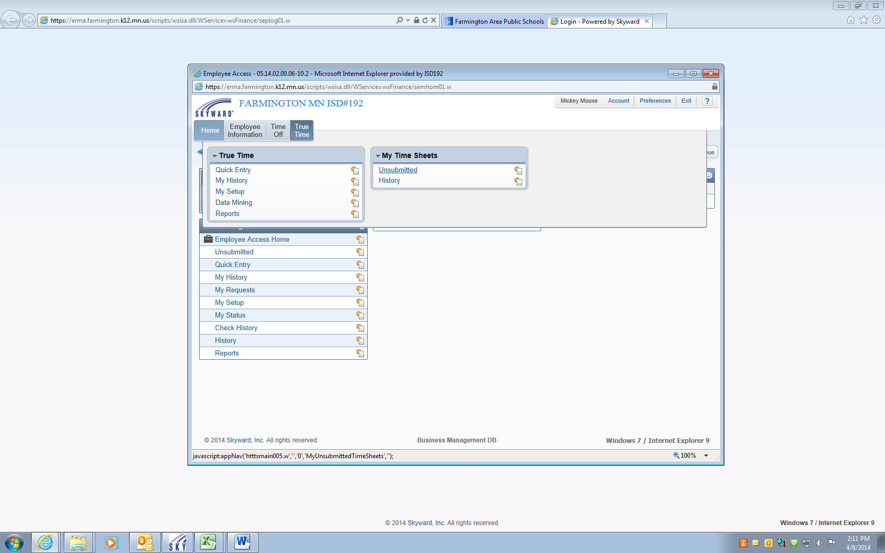

Steps ~

1. Click on True Time
2. Unsubmitted
3. Click on the week needing corrections
4. Click on the date you would like to correct
5. Add or edit an existing punch
6. Fix your time. Make sure your minutes and AM/PM are correct
7. NOTES MUST BE ADDED AS TO YOU WHY YOU ARE MAKING THESE CORRECTIONS
8. Select the correct description as to what position you are working
9. Save

Meal Cancellation ~ You will need to “delete” all lines for that day and reenter your in and out punch to match your schedule.

If you need to “add” a meal break you will enter in the start and end times under step 6 and select lunch under the status code.

Remember when manual adjustments are made the system will NOT take into consideration the rounding rules or the meal deduct.

You will technically see 3 lines of activity showing you your morning shift, a lunch break, and your afternoon shift. So, when manually fixing punches make sure they are reflected in the same manner except when your cancelling a meal then you will just have an in and out punch all on one line.

Step 4

Step 3

Step 1

Step 2

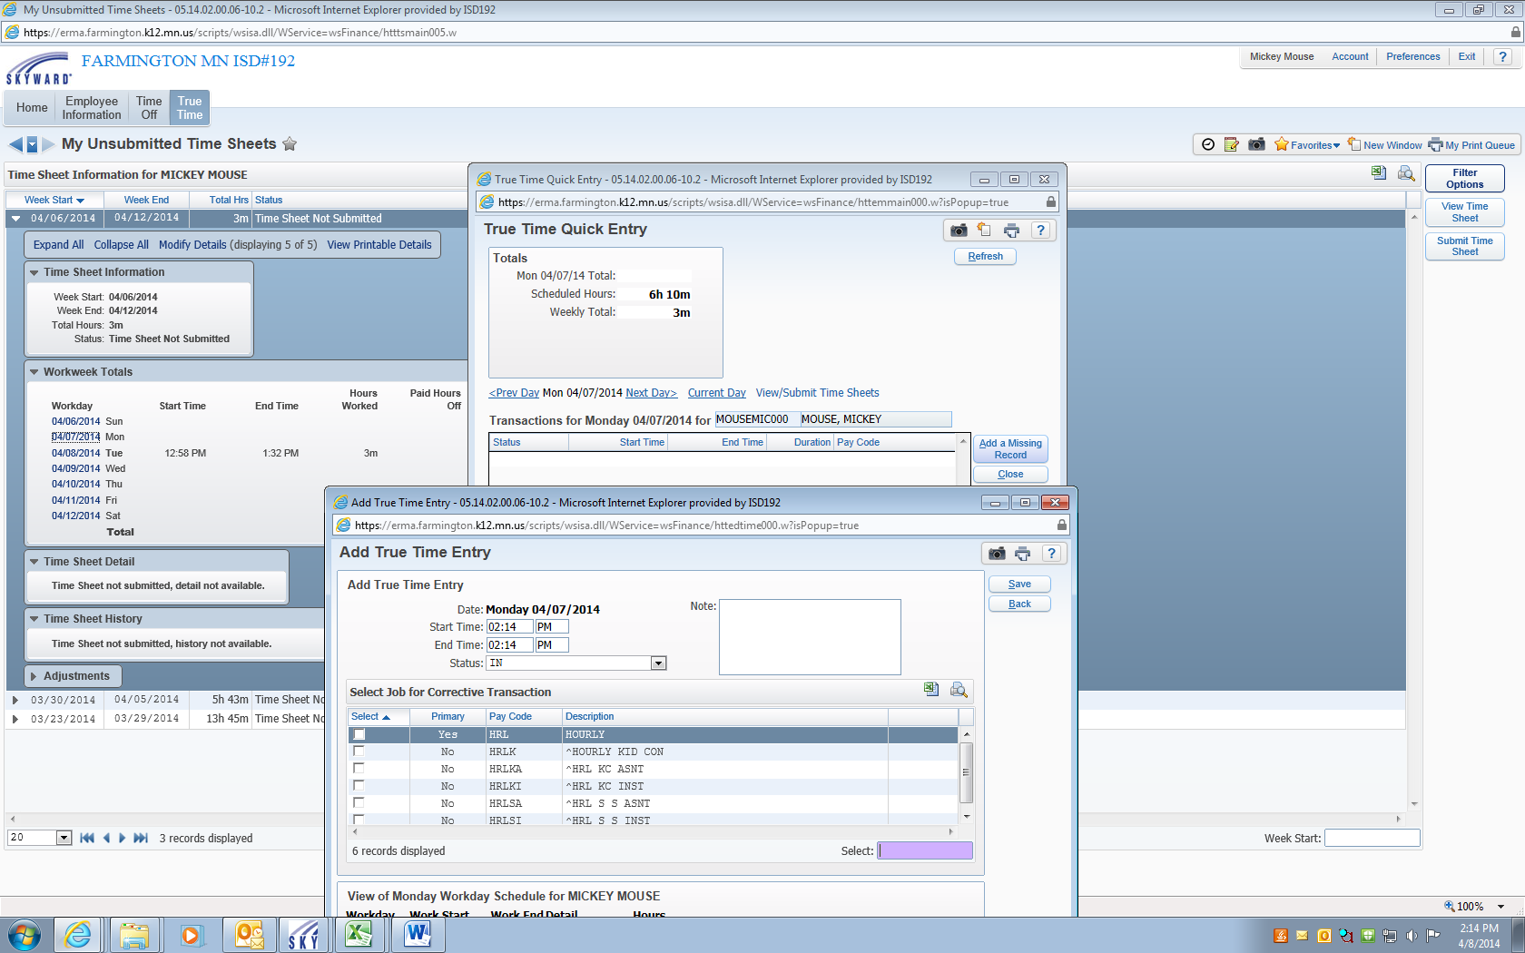

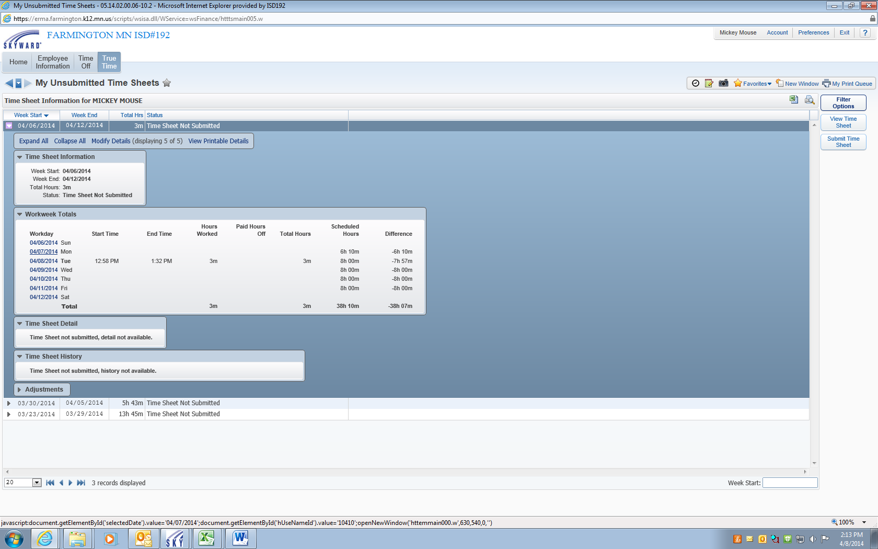

Step 5

Step 9

Step 6

Step 7

Step 8

Submitting Time Card for Payment

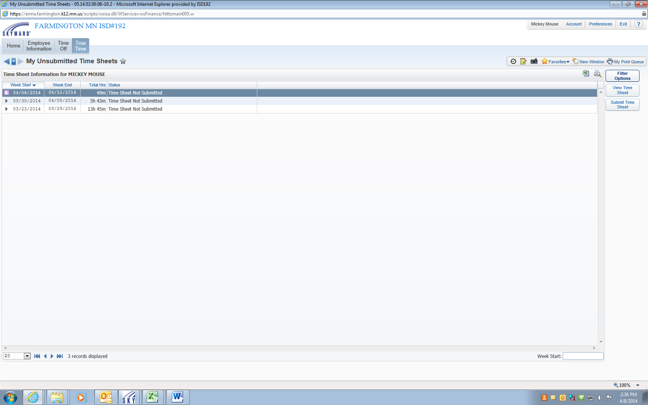

Step 1

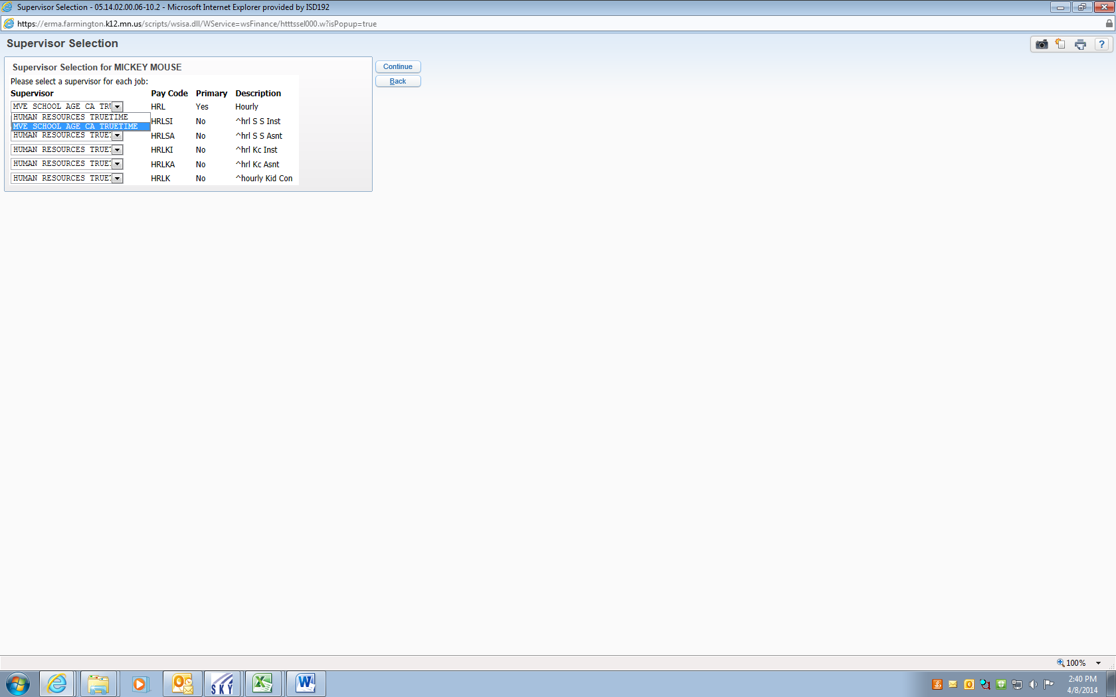

Step 2

The final step after corrections are made is to submit your time sheet to your supervisor for approval.

1. Make sure the week you want to submit is highlighted in blue (if you submit the current work week that we are in, it will lock you out for the rest of the week).

2. Select Submit Time Sheet.

If you have multiple supervisors’ you will want to make sure that for each supervisor it has the correct pay code listed.

**ALL LEAVE MUST BE ENTERED INTO EMPLOYEE ACCESS WITHIN 24 HOURS. ONCE YOUR SUPERVISOR HAS APPROVED YOUR LEAVE THIS WILL POPULATE INTO YOUR TIME CARD. ANY LEAVE APPROVED AFTER SUBMISSION WILL NOT POPULATE THEREFORE PAYMENT MAY NOT BE CORRECT. PLEASE BE VERY ALERT AS TO WHAT YOU’RE ENTERING IN FOR MINUTES. IF YOU ARE TAKING A PORTION OF YOUR DAY YOU MAY WANT TO ENTER YOUR ABSENCE AFTER THE FACT SO THE CORRECT HOURS FOR THE DAY ARE PAID.**

Other Features

My History: Will assist you in the following area’s ~ current statues, work week totals, previous time sheets, upcoming schedule, exception notes, work week schedule, adjustment to be read, and adjustment history

My Setup: Will show you your weeks schedule

Data Mining: Will help you create your own reports for your personal tracking

Reports: Is where you can run reports that are system defined

History: This will show your time cards that have been approved or are pending approval