How to forward your Gmail email to another email address

- While signed into your ISD192 Gmail account click on the Settings icon then click on “See all Settings”.
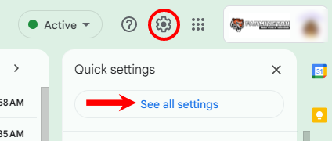

- Click on Forwarding and POP/IMAP, choose Add a forwarding address.
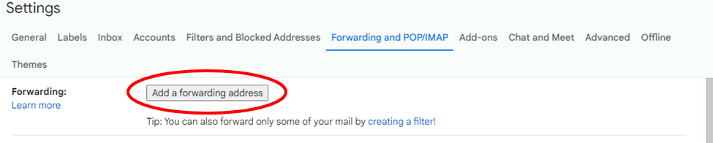

- Type in the email you are wanting to forward your Gmail to, then choose next.
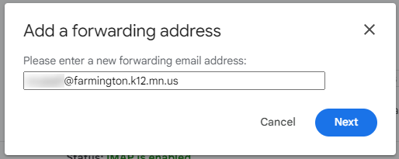

- You will get a pop-up near the top of the window; verify you have entered in the correct email and choose “Proceed” at the prompt if the email looks correct.
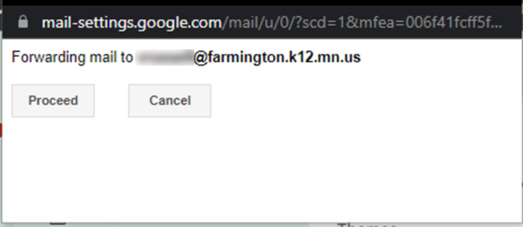

- Another pop-up window will appear, Choose “OK”.
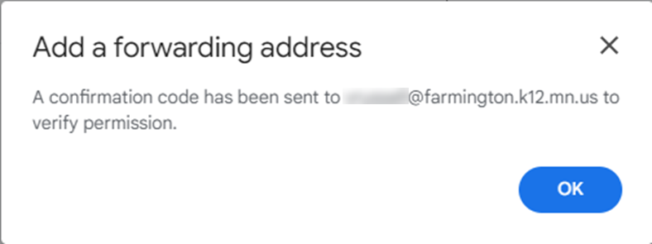

- You will receive an email from ISD192 Team at the address you entered in above (ex: your@farmington.k12.mn.us). It will contain a confirmation code that you will need to copy and paste that into the box in your Gmail settings, then choose “Verify”.
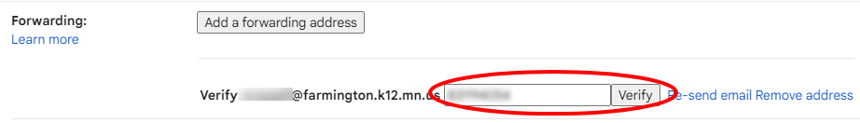

- Choose the radio button next to Forward a copy of incoming mail to and make sure your email address is selected in the dropdown. Then in the box below that choose what you would like to happen to your isd192.org emails after they are forwarded.
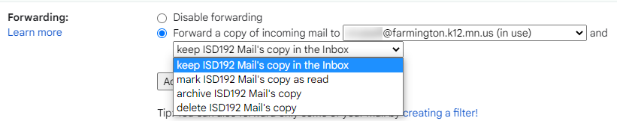

- Once you’ve completed making changes, you need to scroll all the way to the bottom and choose “Save Changes”.
